**Results and Discussion**

**Microbiome Composition at Baseline**

Initial microbiome profiles varied between individuals but exhibited consistent trends within health categories (Figure 1). Healthy microbiomes (K3, K10) were dominated by *Bacteroidaceae*, *Lachnospiraceae*, *Ruminococcaceae*, and *Enterobacteriaceae*, consistent with typical human gut microbiota. In contrast, disease-associated microbiomes were disproportionately enriched in *Prevotellaceae*, which made up over 50% of the community. This baseline compositional divergence provides critical context for interpreting treatment-induced changes.

**Microbiome Shifts During Fermentation**

After 16 hours of in vitro fermentation, pronounced shifts in microbial community composition were observed across all samples (Figure 2). Beta diversity analysis using four distance metrics revealed clear and reproducible trajectories of microbial change, with healthy and disease-associated microbiomes clustering by group. These directional changes suggest that despite individual variation, microbiomes exhibit consistent patterns in response to prebiotic substrates.

**Treatment-Specific Effects on Healthy Microbiomes**

Focusing on healthy microbiomes, distinct patterns of response emerged across treatment categories (Figure 3). Oligosaccharides and gums tended to induce similar compositional changes, while β-glucan and waste stream-derived treatments produced more divergent shifts. At the individual level, certain treatments—such as pomegranate powder and micronized cassava fiber—induced markedly different beta diversity changes compared to other samples. These findings highlight the differential fermentability and microbiome-modulating potential of specific dietary fibers and botanicals.

Quantification of compositional shifts confirmed these trends (Figure 4). Treatments like Betavia Pure WD, cellulose, ginger powder, HiSmooth flax seed fiber, mushroom chitosan, olive flour, pomegranate powder, psyllium husk, and xanthan gum consistently elicited greater beta diversity distances from baseline. These results support the hypothesis that certain dietary components exert stronger microbiota-modulating effects than others.

**Dose–Response Relationships**

Dose–response analysis revealed complex and sometimes microbiome-specific patterns (Figure 5). HiSmooth flax seed fiber and guar gum consistently induced stronger microbial shifts at lower doses, displaying an inverse relationship across all four microbiomes. In contrast, ground beet pulp exhibited a positive dose–response in the K5 microbiome but an inverse relationship in others, underscoring the importance of host-specific factors in shaping prebiotic effects.

**Taxonomic and Functional Shifts**

PERMANOVA-based differential abundance analysis revealed clear taxonomic restructuring across treatments (Figure 6). β-glucan treatments consistently reduced the abundance of genera such as *Faecalibacterium*, *Lachnoclostridium*, and *Peptoclostridium*, while increasing *Extibacter* and *Clostridium*. Notably, treatment clustering did not always align with category labels. For example, a subset of botanicals (e.g., pomegranate, carrot, beetroot, spinach, lemon, and olive flour) clustered with micronized cassava fiber and beet pulp rather than other botanicals, suggesting overlapping functional effects on microbial communities.

**Targeted Effects on Key Genera**

Focused dose–response analysis in microbiome K3 identified treatments with opposing effects on *Faecalibacterium*, a key anti-inflammatory taxon (Figure 7). Samples such as BetaVia Pure WD, ginger powder, cellulose, and micronized cassava fiber increased *Faecalibacterium* abundance in a dose-dependent manner. Conversely, ground beet pulp, dried apple pomace, and lemon powder reduced its abundance at higher concentrations. These patterns align with broader taxonomic trends observed across microbiomes (Figure 8). For instance, *Fusobacterium*—a genus often associated with gut dysbiosis—was consistently reduced by increasing doses of gums, cassava fiber, and ginger powder. Meanwhile, *Blautia* and *Lachnospiraceae UCG-010* were negatively affected by many botanicals and fiber treatments.

**Prebiotic Potential Across Treatments**

To integrate these findings, a Prebiotic Potential Index (PPIa) was calculated based on the relative abundance of beneficial versus harmful taxa (Table 1). All treatments demonstrated some degree of positive modulation, with micronized cassava fiber yielding the highest PPIa. This suggests its potential as a particularly effective dietary intervention for promoting gut health, although the differences between treatments were modest overall.

**Summary and Implications**

Together, these findings illustrate that prebiotic effects are both treatment- and host-dependent. While certain substrate classes (e.g., gums, β-glucans) exhibit predictable impacts, individual treatments such as micronized cassava fiber and pomegranate powder stand out for their unique and potentially beneficial effects on the gut microbiota. The dose–response data further reveal that effective modulation of the gut microbiome may require personalized dosing strategies. The consistent reduction of *Fusobacterium* and support of *Faecalibacterium* by specific treatments point to promising avenues for targeted microbiome interventions aimed at restoring or maintaining gut health.

**Figures and Tables**

**Figure 1.** **Relative abundance profile of microbial families across sixteen different human microbiomes.** FBB0 represents the fecal buffer blank at time 0, while FBB16 corresponds to the buffer after 16 hours of fermentation. Microbiome profiles vary noticeably among individuals. In some cases, *Bacteroidaceae* is the most abundant family, whereas in others, *Prevotellaceae* dominates. Certain microbiomes exhibit a relatively balanced distribution of taxa. Additionally, microbiome composition shifts substantially after 16 hours of fermentation, even in the absence of any treatment.



**Table 1. Sample names and categorized treatment groups.** A total of 21 different samples were classified into nine treatment categories: prebiotic fiber, prebiotic control, vitamin with fiber, vitamin, vitamin synergistic, vitamin synergistic effect, polyphenols, fiber synergistic effect, and postbiotic. These samples were used in the fermentation experiment.

**Figure 2. Alpha diversity of individual microbiomes after 16 hours of fermentation across nine treatment categories.** Alpha diversity was assessed for each individual microbiome after fermentation using four different metrics: Shannon, Chao1, Simpson, and Faith’s Phylogenetic Diversity (PD). Across all diversity indices, treatments including postbiotic, vitamin, vitamin (synergistic effect), vitamin (synergistic), and vitamin with fiber consistently exhibited higher alpha diversity. In contrast, treatments such as polyphenols and fiber synergistic effect were associated with lower diversity. These trends were consistent across different individual microbiomes

(B)

**Figure 3. Microbiome compositional shifts after 16 hours of fermentation under four distance metrics.**  
Beta diversity was calculated using four metrics: Bray–Curtis, Jaccard, unweighted UniFrac, and weighted UniFrac. Principal component analysis (PCA) was performed on each distance matrix, and the first two principal components were plotted for visualization. Arrows represent the directional shift of each microbiome from the baseline (FBB0) to the post-fermentation state across different treatment categories. While individual microbiome profiles primarily drive the clustering, the polyphenol treatment notably shifts multiple microbiomes toward a similar compositional endpoint after fermentation.

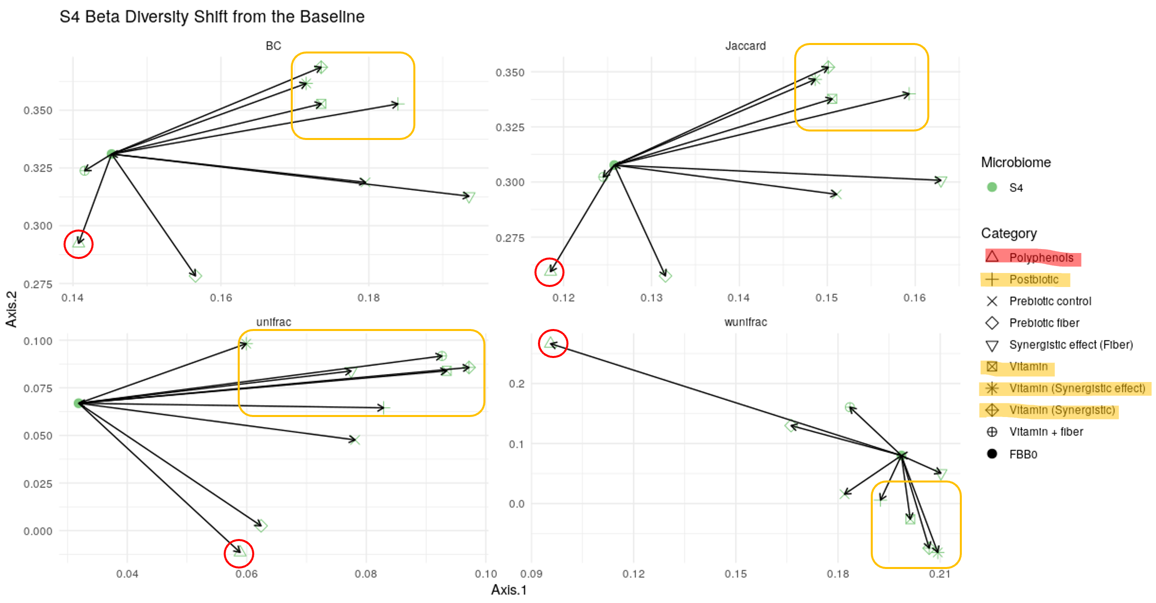

**Figure 4. Classification of treatment category effects based on microbiome similarity.**  
Microbiome beta diversity shifts from the baseline (FBB0) were visualized using principal component plots based on four distance metrics for each individual microbiome. The polyphenol treatment consistently exhibited a distinct effect on microbiome composition compared to other categories. In contrast, treatments including postbiotic, vitamin, vitamin (synergistic effect), and vitamin (synergistic) displayed similar patterns of beta diversity change.

**Figure 6. Heatmap of differentially abundant genera identified by PERMANOVA across samples.**  
Permutational Multivariate Analysis of Variance (PERMANOVA) was used to identify genera with significantly different abundances across treatments. Log<sub>2</sub>-transformed abundance ratios were calculated for each genus, and results were visualized as a heatmap. Warmer colors indicate higher relative abundance. Taxa are organized by co-occurrence patterns, and samples are clustered based on microbial community similarity. Carrot juice with green acerola, red acerola (20% vitamin C), green acerola (34% vitamin C), and the combination of red and green acerola (20% vitamin C) induced similar microbial shifts, characterized by decreased abundance of Escherichia-Shigella, Coprococcus, and Anaerostipes, and increased abundance of [Eubacterium] ruminantium group, Oscillibacter, UCG-003, Odoribacter, and [Eubacterium] eligens group. Similarly, treatments with OGB 28% (OatWell Bran) and Lantmännen OBG-29% GF resulted in comparable effects, including reduced levels of Gemmiger, UCG-002, [Eubacterium] ventriosum group, Lachnospira, Acutalibacter, Monoglobus, and Fusicatenibacter.

(A)

(B)

**Table 2. Gut Microbiome Health Indices: PPIa and GMHI.** **(A) Prebiotic Potential Index (PPIa):** Genera were classified as beneficial or harmful based on previous studies (see Supplementary Materials). Read counts were summed separately for beneficial and harmful taxa, and the Prebiotic Potential Index (PPIa) was calculated as: **PPIₐ = (Reads mapped to beneficial taxa – Reads mapped to harmful taxa) / Total reads.** A higher PPIa value indicates a greater potential for promoting a healthy gut microbiome. Aronox PE 40% polyphenolsshowed a negative impact on gut microbial health across multiple microbiomes, whereas inulin and red acerola (20% vitamin C) demonstrated a more positive effect. **(B) Gut Microbiome Health Index (GMHI):** GMHI was calculated based on the richness of health-prevalent versus health-scarce species. A higher GMHI score reflects a healthier microbiome state. Microbiomes S5, S6, and S14 showed relatively poor health status, while S3, S8, and S16 appeared healthier. Polyphenol treatments were generally associated with negative effects on microbiome health, whereas treatments with vitamins, vitamin synergistic combinations, and vitamin synergistic effects tended to improve microbiome health.